**POOREST TRAINAG-NO TESTAG-NO**

532 classified correctly

174 classified incorrectly

------------------------------------------------

Le prossime predizioni sono giuste

------------------------------------------------

Digit: '0' corrisponde a 'Speed limit (20km/h)'

Digit: '1' corrisponde a 'Dangerous curve to the right'

Digit: '2' corrisponde a 'Road narrows on the right'

Digit: '5' corrisponde a 'End of all speed and passing limits'

Digit: '9' corrisponde a 'End of no passing by vehicles over 3.5 metric tons'

------------------------------------------------

Le prossime predizioni sono sbagliate

------------------------------------------------

Digit: '0' corrisponde a 'Speed limit (20km/h)'

Digit: '1' corrisponde a 'Dangerous curve to the right'

Digit: '2' corrisponde a 'Road narrows on the right'

Digit: '3' corrisponde a 'Pedestrians'

Digit: '4' corrisponde a 'Bicycles crossing'

Digit: '6' corrisponde a 'Go straight or left'

Digit: '7' corrisponde a 'Roundabout mandatory'

Digit: '8' corrisponde a 'End of no passing'

Digit: '9' corrisponde a 'End of no passing by vehicles over 3.5 metric tons'

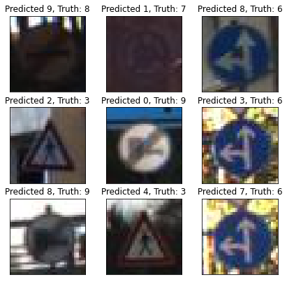

**POOREST TRAINAG-SI TESTAG-NO**

530 classified correctly

176 classified incorrectly

------------------------------------------------

Le prossime predizioni sono giuste

------------------------------------------------

Digit: '0' corrisponde a 'Speed limit (20km/h)'

Digit: '1' corrisponde a 'Dangerous curve to the right'

Digit: '3' corrisponde a 'Pedestrians'

Digit: '5' corrisponde a 'End of all speed and passing limits'

Digit: '6' corrisponde a 'Go straight or left'

Digit: '7' corrisponde a 'Roundabout mandatory'

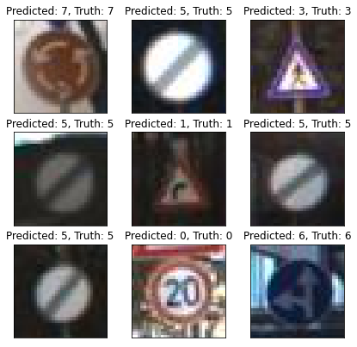

------------------------------------------------

Le prossime predizioni sono sbagliate

------------------------------------------------

Digit: '1' corrisponde a 'Dangerous curve to the right'

Digit: '2' corrisponde a 'Road narrows on the right'

Digit: '3' corrisponde a 'Pedestrians'

Digit: '4' corrisponde a 'Bicycles crossing'

Digit: '6' corrisponde a 'Go straight or left'

Digit: '7' corrisponde a 'Roundabout mandatory'

Digit: '8' corrisponde a 'End of no passing'

Digit: '9' corrisponde a 'End of no passing by vehicles over 3.5 metric tons'

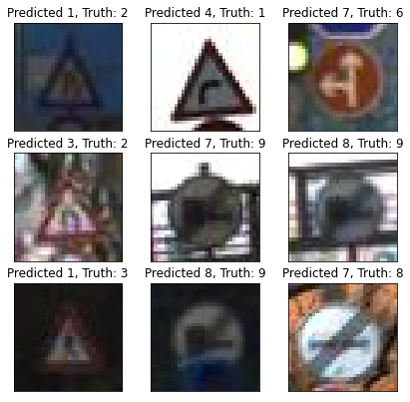

**POOREST TRAINAG-NO TESTAG-SI**

414 classified correctly

292 classified incorrectly

------------------------------------------------

Le prossime predizioni sono giuste

------------------------------------------------

Digit: '0' corrisponde a 'Speed limit (20km/h)'

Digit: '1' corrisponde a 'Dangerous curve to the right'

Digit: '2' corrisponde a 'Road narrows on the right'

Digit: '5' corrisponde a 'End of all speed and passing limits'

Digit: '6' corrisponde a 'Go straight or left'

Digit: '9' corrisponde a 'End of no passing by vehicles over 3.5 metric tons'

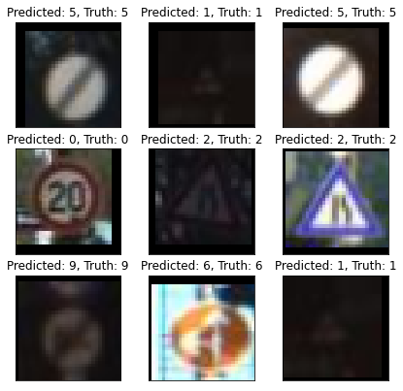

------------------------------------------------

Le prossime predizioni sono sbagliate

------------------------------------------------

Digit: '0' corrisponde a 'Speed limit (20km/h)'

Digit: '1' corrisponde a 'Dangerous curve to the right'

Digit: '2' corrisponde a 'Road narrows on the right'

Digit: '3' corrisponde a 'Pedestrians'

Digit: '4' corrisponde a 'Bicycles crossing'

Digit: '6' corrisponde a 'Go straight or left'

Digit: '7' corrisponde a 'Roundabout mandatory'

Digit: '8' corrisponde a 'End of no passing'

Digit: '9' corrisponde a 'End of no passing by vehicles over 3.5 metric tons'

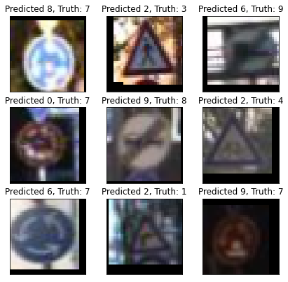

**POOREST TRAINAG-SI TESTAG-SI**

526 classified correctly

180 classified incorrectly

------------------------------------------------

Le prossime predizioni sono giuste

------------------------------------------------

Digit: '0' corrisponde a 'Speed limit (20km/h)'

Digit: '1' corrisponde a 'Dangerous curve to the right'

Digit: '2' corrisponde a 'Road narrows on the right'

Digit: '4' corrisponde a 'Bicycles crossing'

Digit: '6' corrisponde a 'Go straight or left'

Digit: '8' corrisponde a 'End of no passing'

Digit: '9' corrisponde a 'End of no passing by vehicles over 3.5 metric tons'

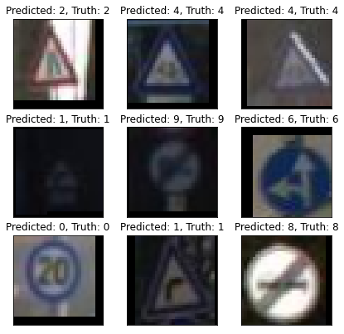

------------------------------------------------

Le prossime predizioni sono sbagliate

------------------------------------------------

Digit: '1' corrisponde a 'Dangerous curve to the right'

Digit: '2' corrisponde a 'Road narrows on the right'

Digit: '3' corrisponde a 'Pedestrians'

Digit: '4' corrisponde a 'Bicycles crossing'

Digit: '6' corrisponde a 'Go straight or left'

Digit: '7' corrisponde a 'Roundabout mandatory'

Digit: '8' corrisponde a 'End of no passing'

Digit: '9' corrisponde a 'End of no passing by vehicles over 3.5 metric tons'

